BREATHING IDEAS
♥ Always breathe in thorough your nose and out through your mouth♥

(Imagine smelling something delicious and then blowing out the candles on a cake) Make sure your out breath is a LONG, SLOW, BLOW……until you run out of puff!

Some different Ideas for practising Breathing:

- Belly Breathing (place a toy or your hands on your belly. Breathe in and fill your tummy with air. Watch your toy or hands rise. Breathe out and let the air come out. Watch your toy or hands fall. Particularly good for bedtimes!).
- Ball Breathing (expand when breathing in and close when breathing out).
- Finger breathing (trace up and down your fingers – on the front, back or between fingers. Breathe in for tracing up and breathe out for tracing down)
- Feather Breathing (Breathe in and blow the feather for as long as possible when you breathe out – how long can you bend the feather over with your out breath?)
- Balloon Breathing (Breathe in through your nose and breathe out into the balloon. Pinch and hold the balloon between breaths) Don’t worry if your balloon doesn’t actually inflate – you need a lot of puff to make this happen!
- Make up your own! Can you add physical actions of your own? e.g. swinging your arms or bending your body? Can you find a way of doing breathing with a favourite toy? Or your pet?

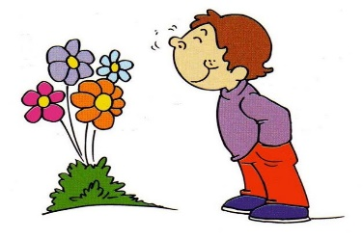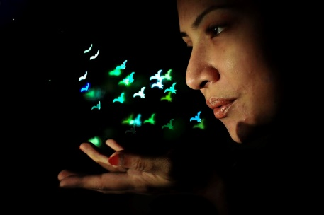
This Photo by Unknown Author is licensed under CC BY-NC-ND
Breathe in through your nose Blow out through your mouth
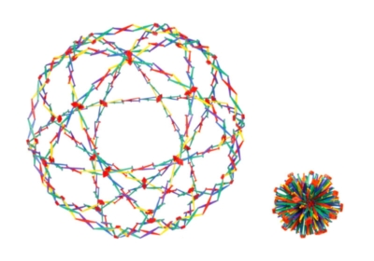
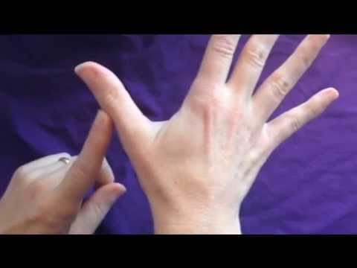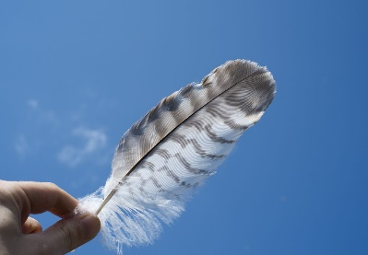

Belly breathing helps to calm the body and the brain, helps with concentration, reduces stress and worry and gives you control over your emotions.

